Name of project/service
Evaluation plan

Title of project

Sign-off Date

Author

Project Lead(s)

Steering group/board

Verto reference

Version control
Date | Version | Author | Action

Contents

Introduction and background xx

Evaluation purpose xx

Evaluation aims xx

Evaluation objectives/questions xx

Design and Methods xx

Ethics and governance xx

Patient and Public Involvement xx

Evaluation team and resources xx

Timeframes xx

Outputs xx

Other considerations xx

References xx

Evaluation Planning Checklist
Ensure you have thought about the following:
- The evaluation cycle – visit the Evaluation Toolkit and ARC West Evaluation resources
- If the evaluation will be undertaken internally, or externally procured and any budget for this
- Evaluation team and resources, including who is responsible for planning, delivery and write up
- Any patient and public involvement in evaluation planning, delivery and write up
- The aims and objectives of your project/programme
- Your evaluation purpose, audience(s), aims and objectives/questions i.e. what you need to know from your evaluation and why
- The ethical implications of the evaluation and how they will be mitigated and reviewed
- The evidence you need to answer your evaluation questions, and how you will collect/source it
- The population(s) you may collect new data from, and any accessibility considerations
- How you will analyse and report on your data
- The outputs, dissemination strategy and how your findings will be used
- The evaluation timeframe, including any specific phases or stages
- Any anticipated risks or issues

Introduction and background
Briefly describe the programme, project, service, intervention, initiative or product being evaluated. Most of this information will be in your service specification, business case or Verto entry. You might want to include references to support the description of your work.
- What were the drivers - where has the need for the work come from?
- What are the aims (what will it achieve)? What are the objectives (how will it achieve the aims)?
If relevant, briefly describe the components of your programme/project. Methods like theory of change or logic modelling (read more in the Identify and Understand section of the evaluation toolkit here) may help to articulate the objectives of your project and can be used to develop evaluation questions and plans. Table 1 gives you an example of how you could link the components of your programme to your aim(s).
Tip: you can use your evaluation to report against objectives set out in your Equality Impact Assessment e.g. monitoring access of people who don’t speak English as a first language.

Table 1: Example programme aims and components of a new Musculo-Skeletal (MSK) care pathway
Programme/project Aims | Programme components: MSK Services/initiatives
 | Pain management course | Health Optimisation | Shared Decision Making | Self-management apps | First Contact Practitioners
- Keep people healthy
- Reduce low value activity
- Provide equitable services
- Improve performance
- Improve clinical outcomes for patients
- Improve patient experience

Evaluation purpose
- Why are you doing an evaluation? What is the ‘extra’ that you are adding to your routine monitoring data collection and analysis, that you hope to achieve by carrying out an evaluation?
- What will you do with the findings? Who are your audience(s)?
Example: to generate evidence to feed into a funding bid or business case or to generate learning around quality improvements to make changes to a clinical pathway.

Evaluation aim
- What do you intend to find out?
Example: To understand the impact of introducing new initiatives into the Musculo-skeletal (MSK) pathway in BNSSG.

Evaluation objectives
- What questions will you need to answer to meet the aim of your evaluation?
These will become your evaluation objectives (or evaluation questions). Table 2 builds on Table 1 to help identify these.

Table 2: Example developing an evaluation question for a new MSK care pathway
Programme/project component | Planned benefit of programme/project component | Evaluation Objective | Evaluation question | Measure/ metric | Data source
Shared Decision Making | Patients are supported by clinicians to make decisions that are right for them | To determine if patients feel supported by clinicians to make decisions about their care, that are right for them | Do patients feel supported by clinicians to make decisions about their care? | (e.g.) 100% of patients feel that they were supported by clinician(s) to make decision(s) about their care, that were right for them | Patient feedback survey
Tip: By clearly defining your evaluation aim(s) and objectives/questions, you can select the methods that will generate results that will tell you what you need to know!

Design and methods
Describe the methods you intend to use:
- What is your overall approach to the evaluation (e.g. quantitative/qualitative/mixed methods; formative/process/summative)?
- What evidence will you need to answer your evaluation aims and objectives? (Specify your data collection methods and sources and how they link to your evaluation aims and objectives in Table 4)
- How will you analyse your data?
Tip: Demand for ‘quick results’ needs to be balanced against the need for a robust and rigorous evaluation approach. Be pragmatic and remember that this is an opportunity to generate findings that could inform a real shift in how services are delivered and accessed by our population.

Data collection points
Your project will include different data sources. Figure 1 shows a map of a clinical pathway, and the points where data could be collected from provider and commissioning organisations. This type of mapping exercise is useful in identifying available routine data, how to access it and which elements of a pathway are within the scope of your evaluation.
Figure 1: data collection along a clinical pathway
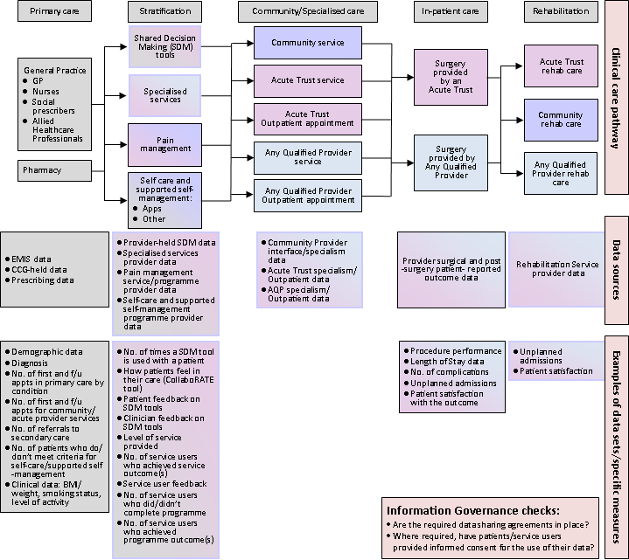

Existing data
Due to capacity demands, it is advised that evaluations draw on existing data where possible (see Table 3), keeping in mind high level system data, project specific Key Performance Indicators (KPIs) and national data sets for benchmarking. However, evaluations should not be restricted by the data that is available, and it may be necessary to collect additional data. See Table 3 for how to access existing local data sources.

Data collection methods
Consider the population(s) you wish to collect new data from for your evaluation, and how you will do it. E.g. are online surveys the best way of collecting data from these groups? Will everybody have access to a computer? Does the survey need to be available in languages other than English? Contact your organisation’s Patient and Public Involvement (PPI) Lead for guidance.
See Clinical Effectiveness team hub page for useful data collection tools such as the Validated Outcome Measures Index (VOMI). You can populate Table 4 with your existing and new planned data sources and tools.

Table 3: Existing data sources and tools to support new data collection
Type of data | Source/Tool | Specific data
Quantitative | BNSSG Integrated Care Board (ICB) Business Intelligence (BI) Team - contact using their current BI Work Request Form on the hub here) and email it to bnssg.business.information@nhs.net. | BI can access local and national, patient-level and aggregated datasets available. See examples here:
Quantitative | PHM ExplorerR - email bnssg.business.information@nhs.net to request access. | A BNSSG open source tool for Population Health Management:  - Summary graphs and descriptive statistics for high level overview of the population.  - Patient-level ‘theoplots’, charting activity utilisation for individuals across multiple healthcare settings.  - Regression-based risk stratification for analysing and predicting differences in patient activity utilisation and spend.
Quantitative | Bristol, North Somerset and South Gloucestershire (BNSSG) System-Wide Dataset - email bnssg.business.information@nhs.net for more information. | The dataset consists of two tables:  1. Attributes (patient characteristics)  - demographic data (age and sex)  - clinical information (long term conditions)  - socio-economic information  - other data e.g. smoking status  2. Activity (patient contacts)  - point of delivery (secondary care, inpatient, elective)  - specialty (e.g. dermatology)  - provider  - dates, times and cost
Quantitative | NHS Futures Platform - submit your email address on the home page to request access, then email workspace administrators for access to specific workspaces | Local, regional and national datasets and dashboards.
Quantitative and Qualitative | BNSSG Insights and Engagement Team national and local Insights Digests and Citizens Panel survey results (available via the Hub) | Digest of data relating to public attitudes and behaviours relating to health care service uptake

Note: If requesting support from the ICB BI team they recommend being as clear as possible about the scope of the data request and encourage use of the BI work request form.

Table 4: Evaluation Objectives/Questions, Measures and Data Sources
Evaluation objectives/questions | Measures | Data Sources / Tools | Responsibility and Timescale
Prompt: What do you need to know to meet the aim of your evaluation? | Prompt: How will you know? e.g. could be KPIs or targets, but not necessarily | Prompt: What will you use to find out? | Prompt: Who will do it and when?
e.g. Do patients on the MSK pathway feel supported by clinicians to make decisions about their care? | e.g. Patients on the MSK pathway report whether they felt supported by clinicians to make decisions about their care  e.g. Improved Friends and Family Test (FFT) results for MSK pathway services since the implementation of Shared Decision Making | e.g. Generic patient survey  FFT data | e.g. Weekly:  Survey link sent to patients who have attended a clinic appointment in previous week  Monthly:  Service Administrator to download survey responses and send to ICB Service Improvement Facilitator for analysis  Monthly FFT data report from BNSSG ICB BI Team

Ethics and governance
Ensure you have considered what the ethical implications of the evaluation are and how they will be mitigated and reviewed. For example, will personal data be anonymised? Use Governance and Ethics guidelines for evaluation in health social care here.

Patient and Public Involvement
How will you involve patients and the public in planning, delivering and writing up your evaluation? Use Guidelines for patient and public involvement in evaluation for ideas about engagement with relevant groups and contact your organisation’s Patient and Public Involvement (PPI) Lead for further guidance.

Evaluation team and resources
- Can the evaluation be carried out internally or can it/does it need to be externally procured?
- Who will be involved in the evaluation? Tasks include; planning, coordinating, designing tools, collecting data, analysing and writing up (using the Clinical Effectiveness evaluation reporting template available on the hub).
- The Clinical Effectiveness team can review evaluation plans and outputs (reports), if required. The team can create and host online surveys and download response data as requested.

Timeframe
- When will the evaluation begin?
- When does it need to be completed?
- Are there phases or stages? When will they each begin and end? Who do you need to liaise with to operationalise each stage?

Outputs
- What will you produce e.g. report? This should be informed by the background to your Evaluation (p.3-4)
- Who is the audience?
- How will this be disseminated or shared? Do you need to consider any specific access needs?
- Will you create recommendations to continue and/or expand a service?

Dissemination tips:
- Could your evaluation be disseminated via the West of England AHSN Evidence Repository here, to inform future service and/or evaluation design? Please email the Clinical Effectiveness Team for information.
- Do you want to put on an event to showcase your findings and/or process?
- Do you want your evaluation to be written up to add to the relevant evidence-base e.g. academic journals or grey literature databases?

Other considerations
List any anticipated risks or issues. If not applicable delete this section.

References
The original evidence used in the service specification can also be reference here and included in the background section.

